**FLEET DATABASE DESCRIPTION**

Fleet Version 5.0.2

(As of March 15, 2021)

# **dbo.tblactivate**

* Activate / Deactivate function

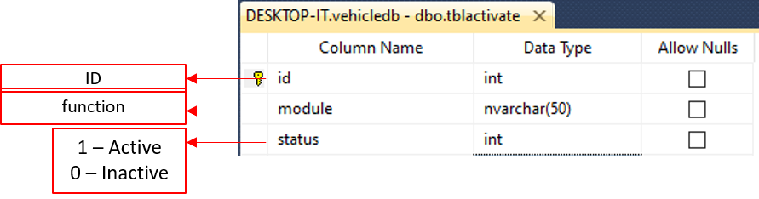

# **dbo.tblassess**

* List of assessment

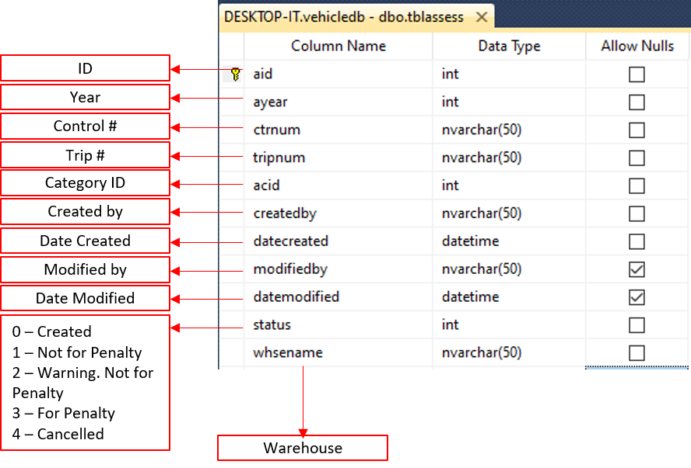

# **dbo.tblassesscat**

* 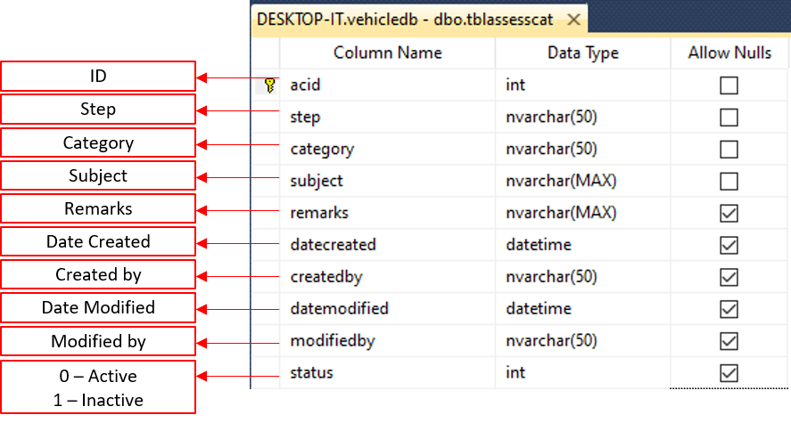List of assess category

# **dbo.tblassesscom**

* List of comments on assessed trip

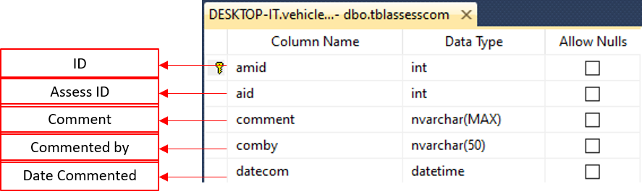

# **dbo.tblassessemp**

* 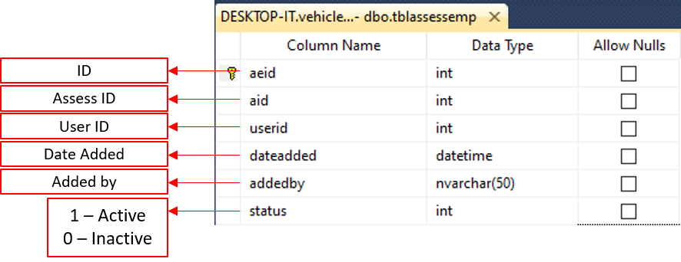List of assessed employees

# **dbo.tblbody**

* List of Body Type

# **dbo.tblcompany**

* List of Company

# **dbo.tblcuspoi**

* List of POI for a specific Customer

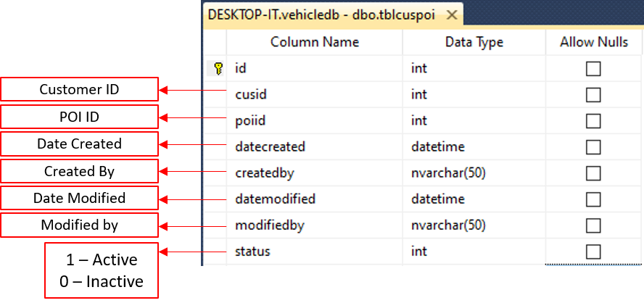

# **dbo.tblcustomer**

* 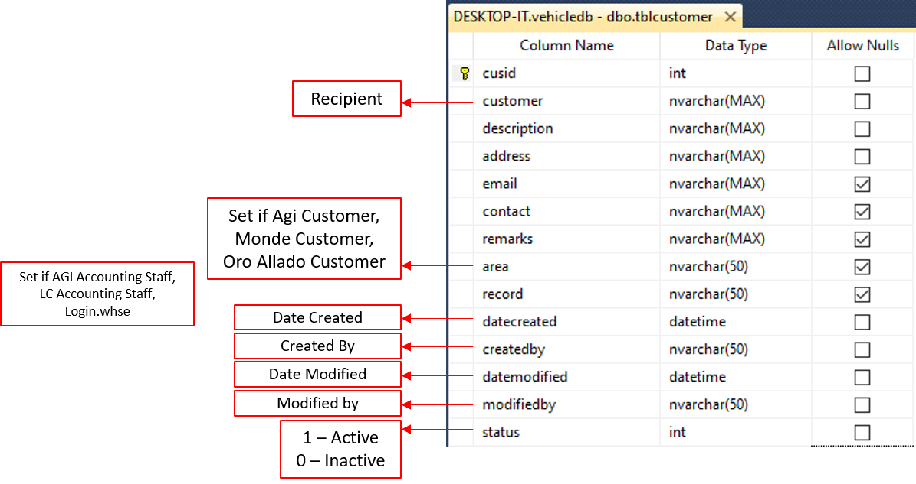List of Recipients

# **dbo.tbldiesel**

* Diesel parameters of trucks

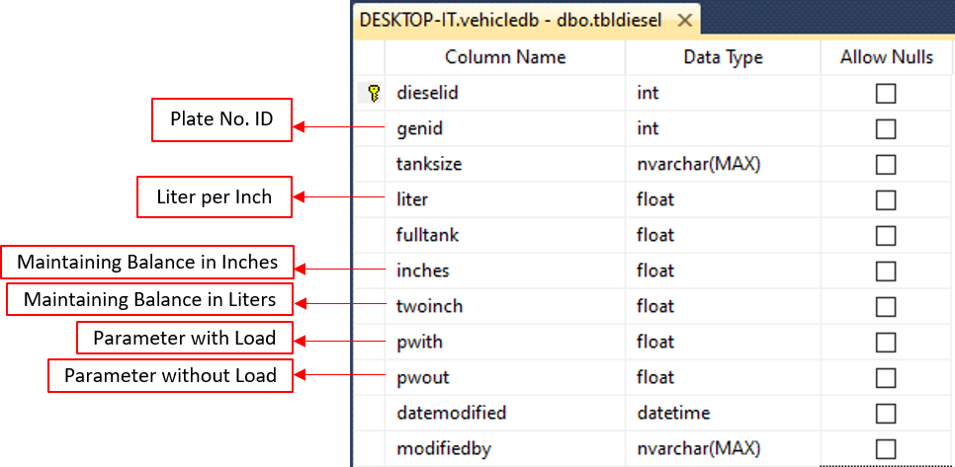

# **dbo.tbldispatchstp1**

* 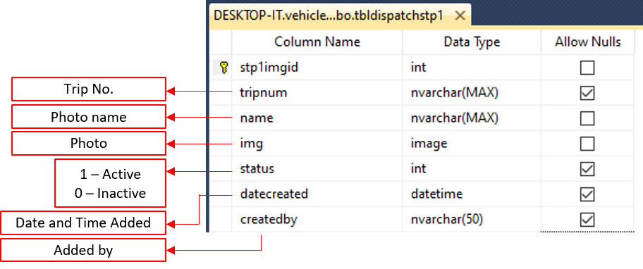Photos in Step 1

# **dbo.tbldispatchstp2**

* 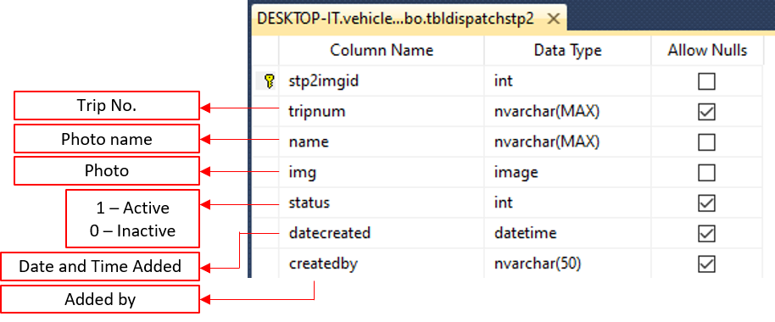Photos in Step 2

# **dbo.tbldispatchstp3**

* 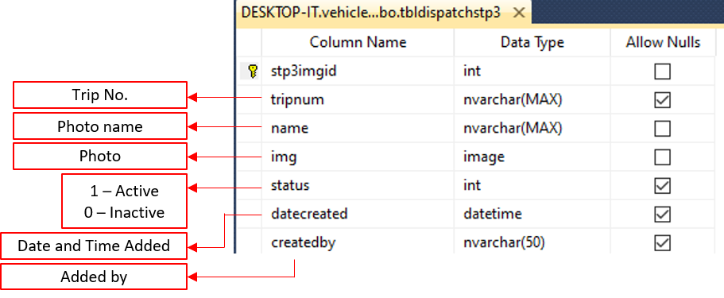Photos in Step 3

# **dbo.tbldispatchstp4**

* 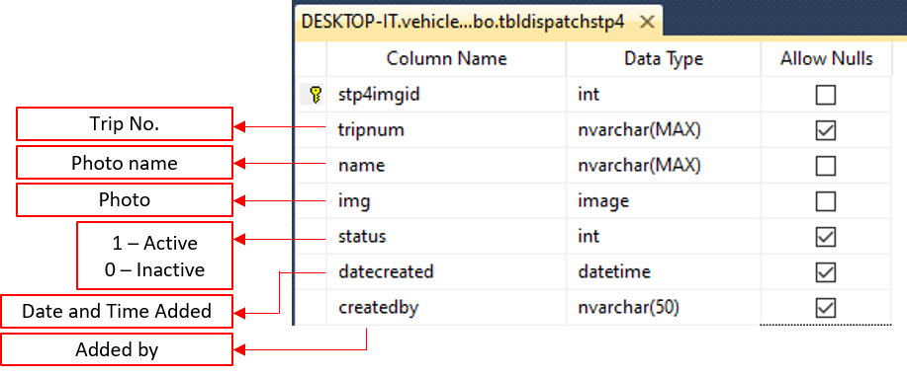Photos in Step 4

# **dbo.tbldispatchstp5**

* 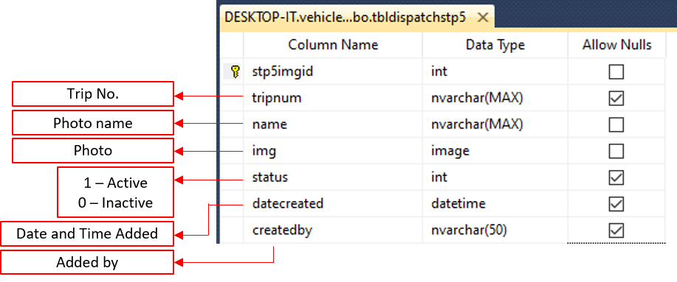Photos in Step 5

# **dbo.tbldispatchstp6**

* 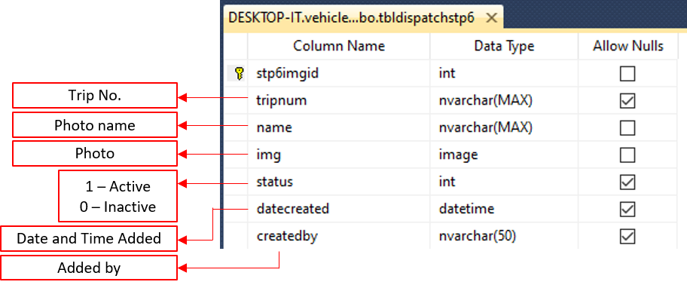Photos in Step 6

# **dbo.tbldispatchstp7**

* 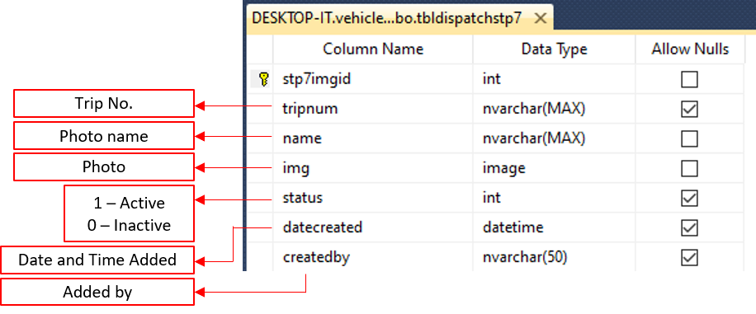Photos in Step 7

# **dbo.tbldispatchstp8**

* 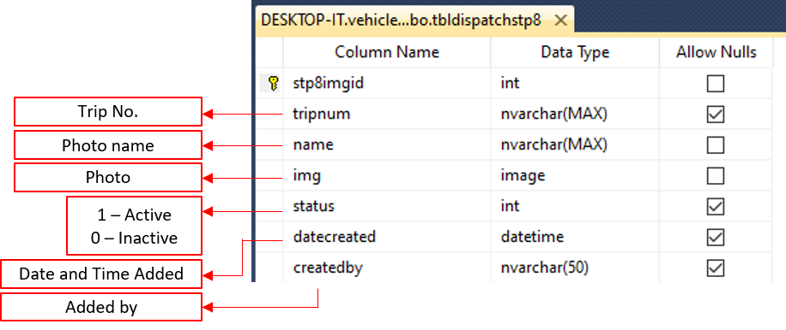Photos in Step 8

# **dbo.tbldispatchstp9**

* 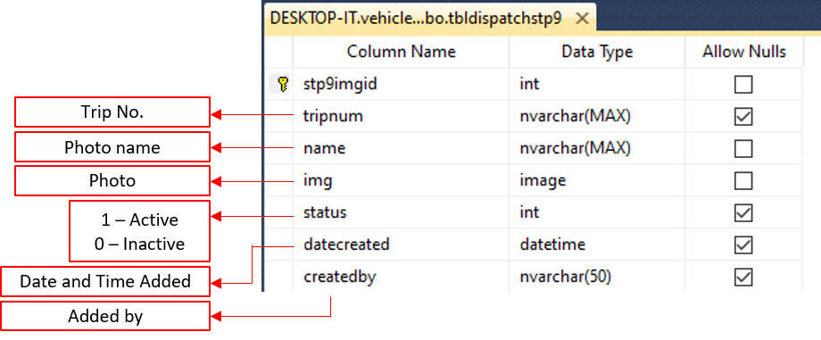Photos in Step 9

# **dbo.tbldispatchsum**

* 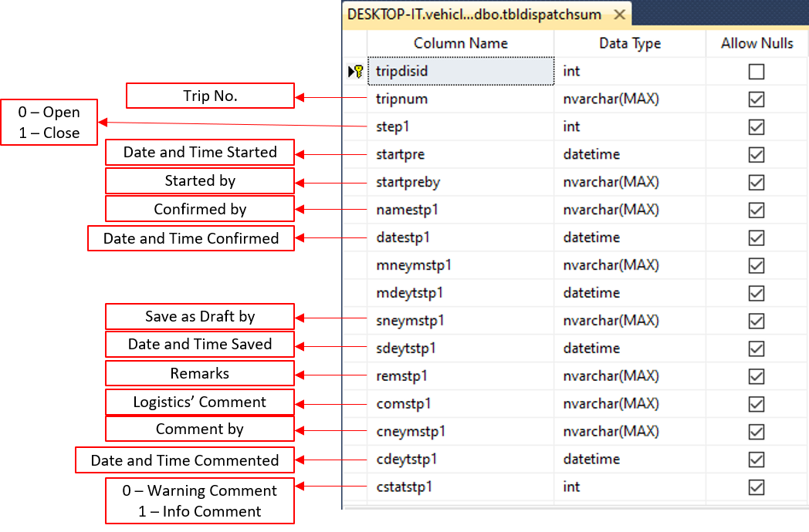Status of every step in Trip Dispatching

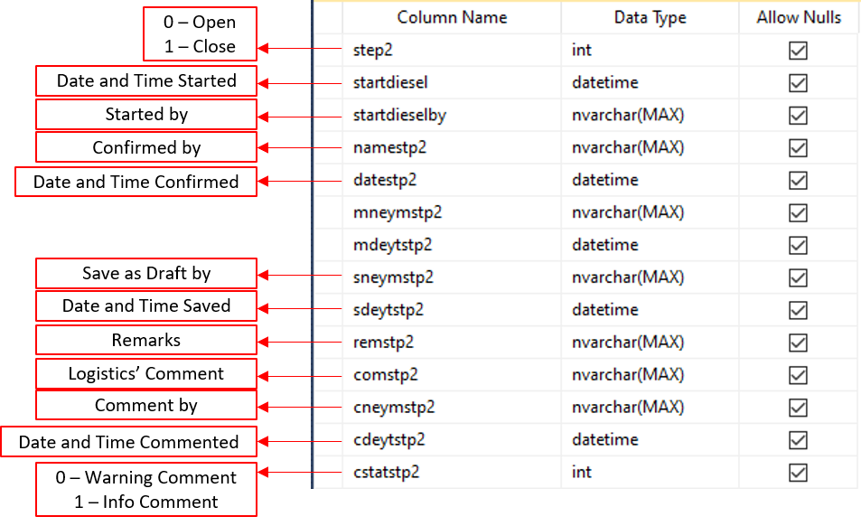

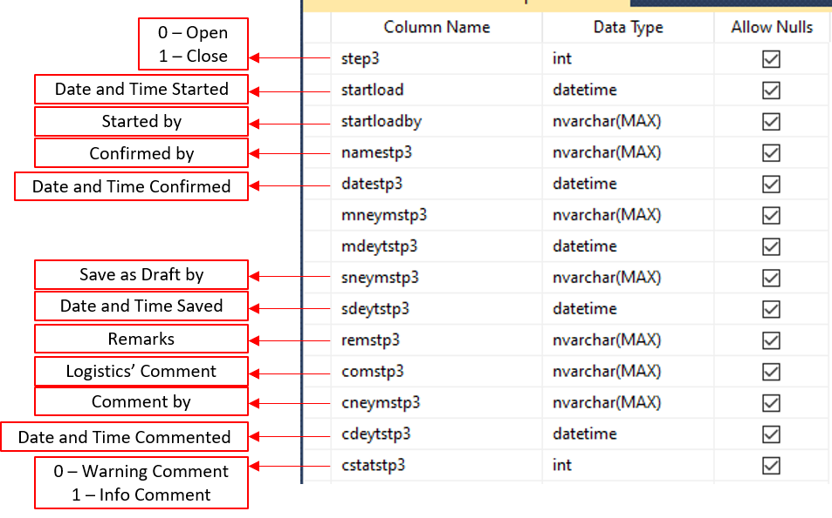

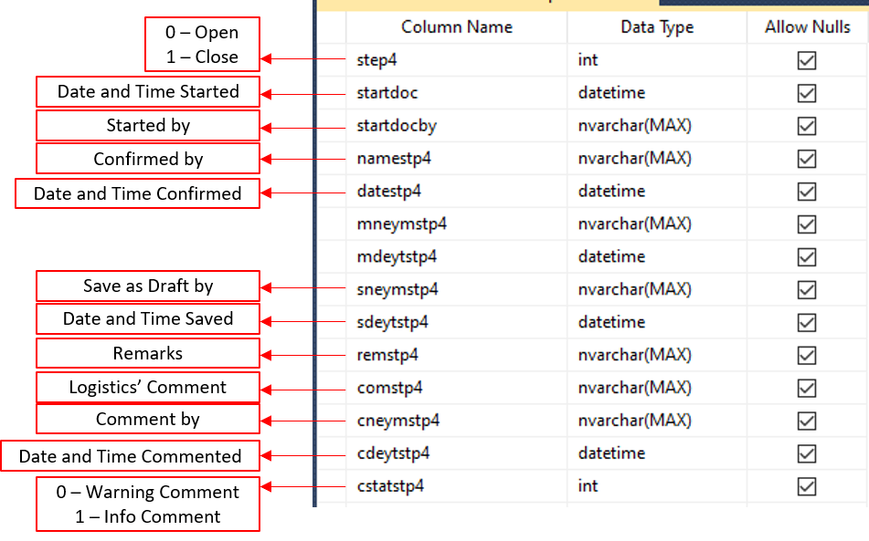

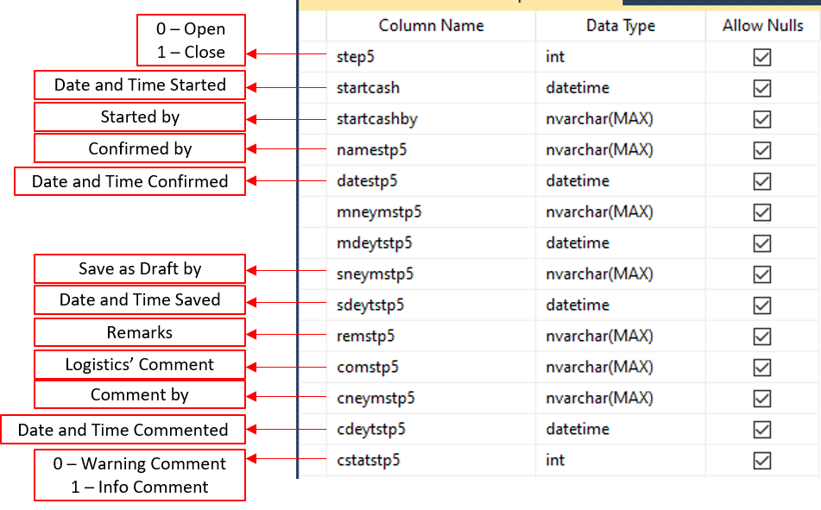

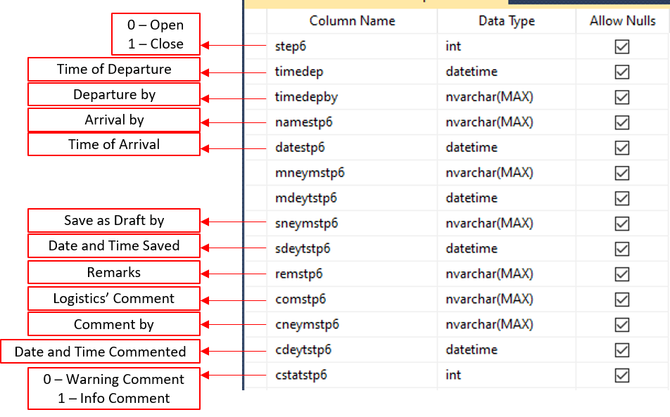

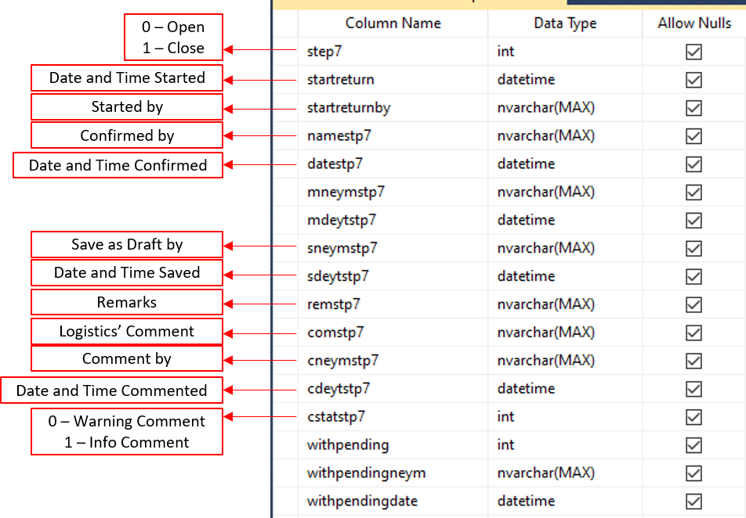

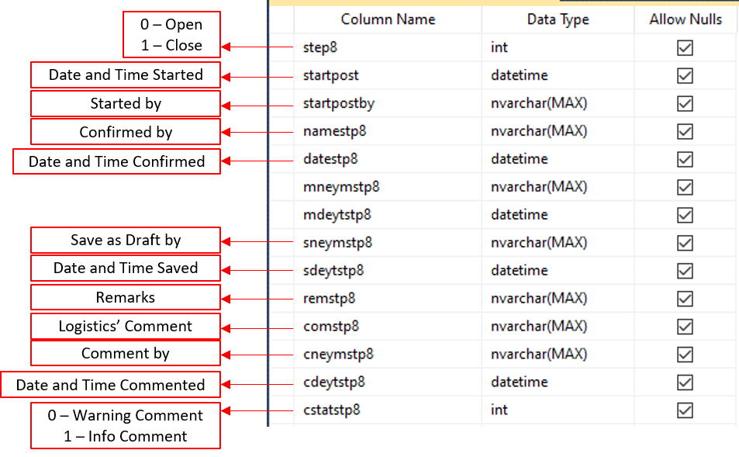

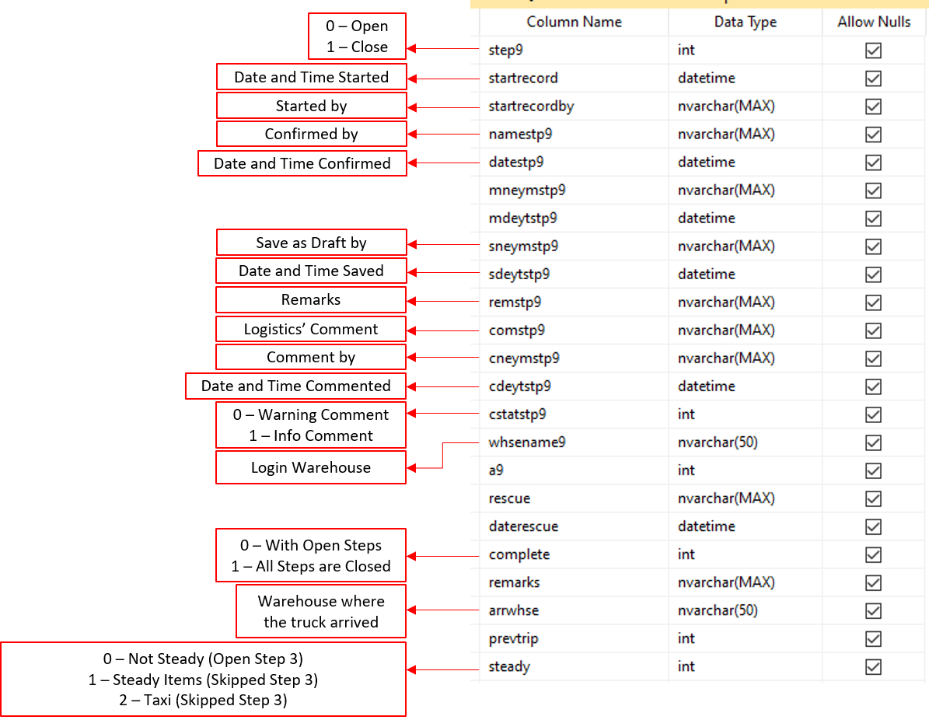

# **dbo.tbldriver**

* 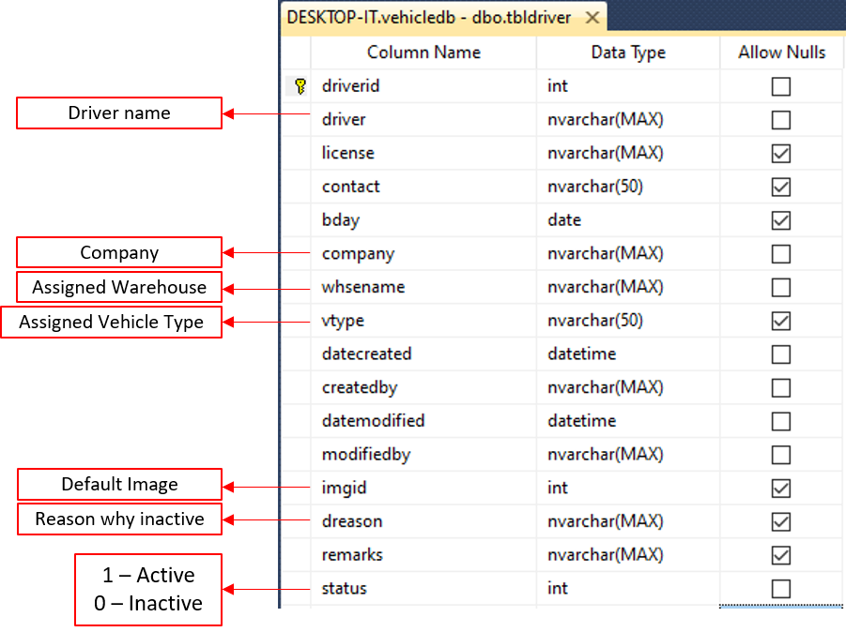List of Drivers

# **dbo.tblhelper**

* List of Helpers

# **dbo.tblgeneral**

* List of Plate#

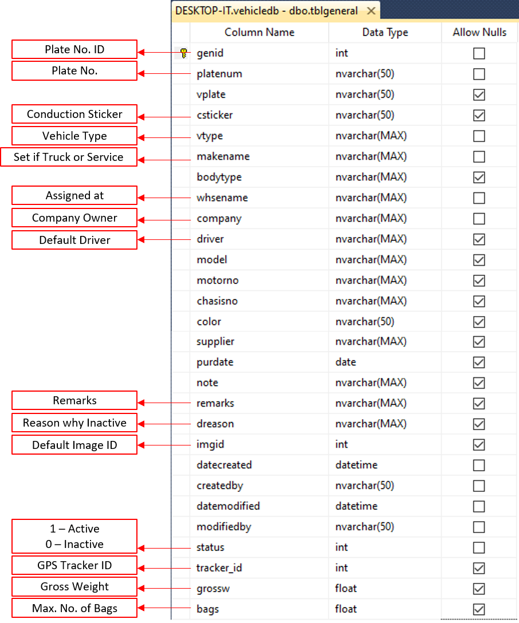

# **dbo.tblgpsaccount**

* 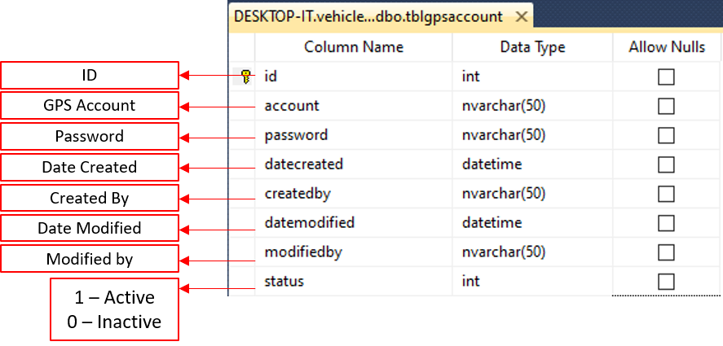GPS account for GPS API parameter, to get Hash

# **dbo.tblimage**

* 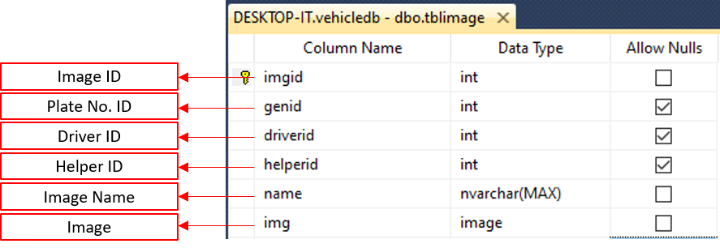List of Trucks / Service Vehicles / Driver / Helper images

# **dbo.tbllogin**

* 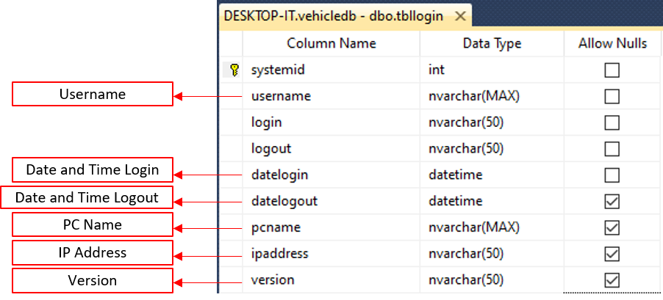Login Logs

# **dbo.tblmake**

* Truck or Service Vehicle

# **dbo.tblmscheckup**

* 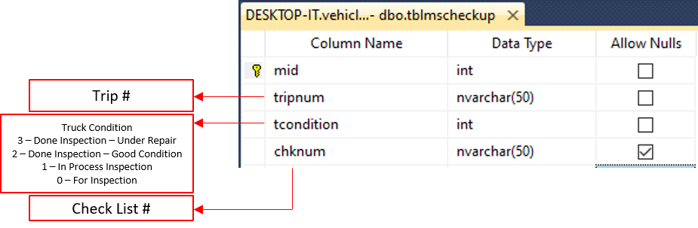Motorpool Inspection Status

# **dbo.tblmsimg**

* List of attachments for back up motorpool inspection

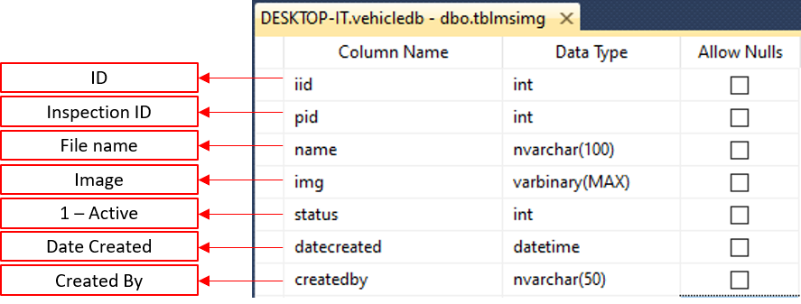

# **dbo.tblmsinspect**

* List of motorpool inspection (back up only)

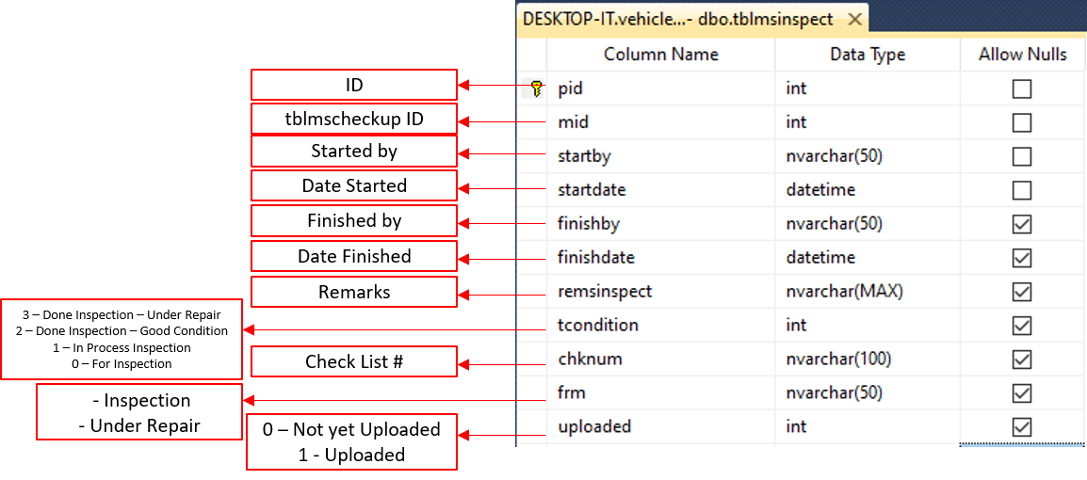

# **dbo.tblorcat**

* List of Item Category

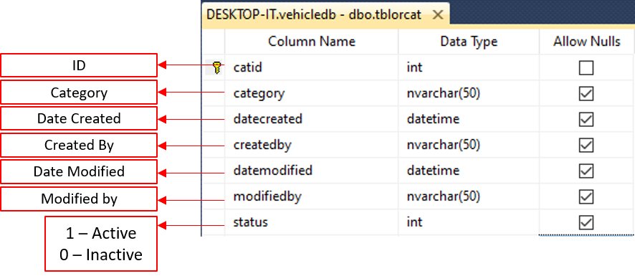

# **dbo.tblorder**

* List of Items ordered

# **dbo.tblorderedit**

* Create order edit Logs

# **dbo.tbloredit**

* Logs for editing Reference number

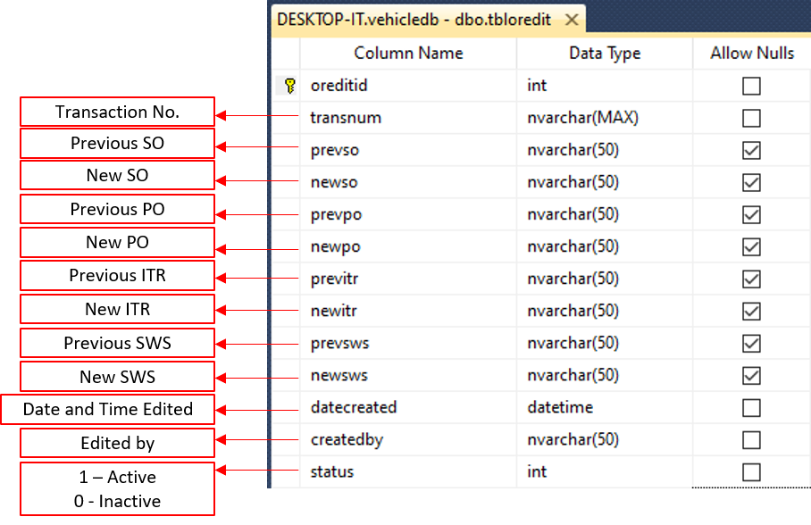

# **dbo.tblorimage**

* 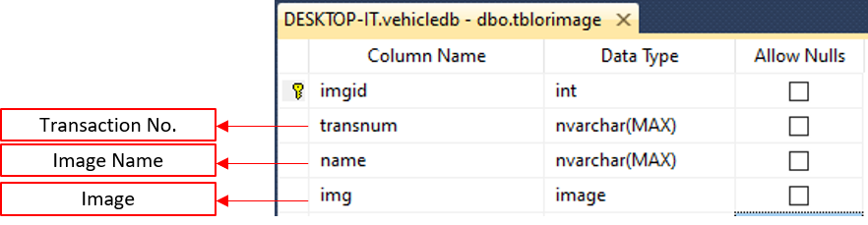Photos in Create Order

# **dbo.tbloritems**

* 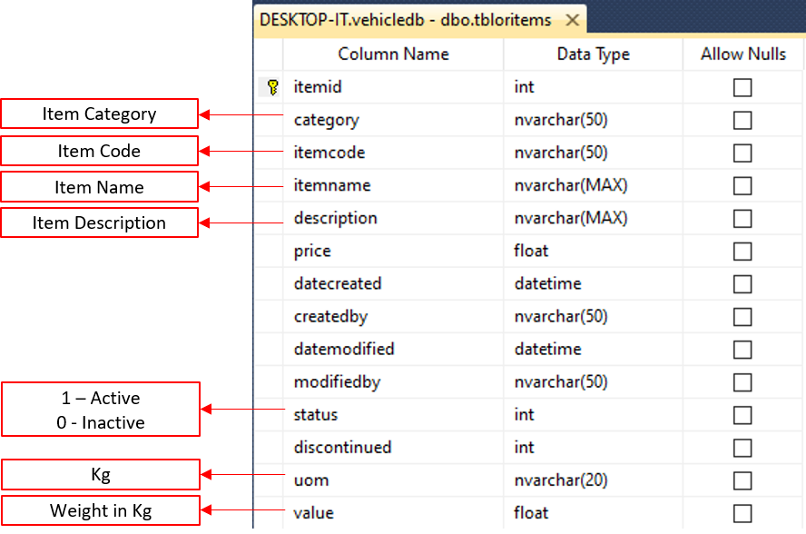List of Items

# **dbo.tblortrans**

* 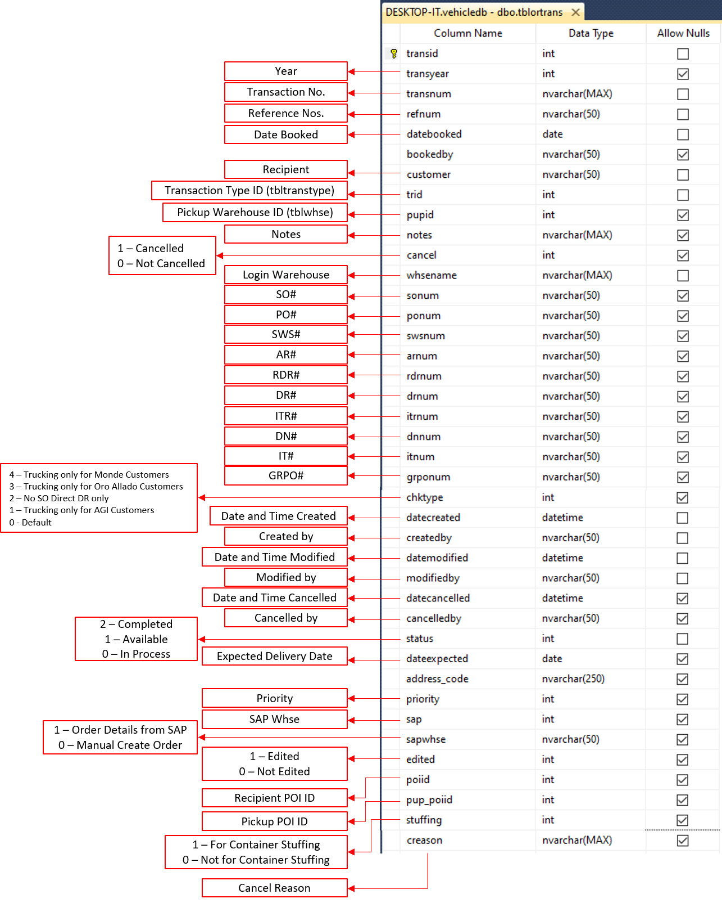List of Order Transactions

# **dbo.tblpoi**

* List of GPS POI

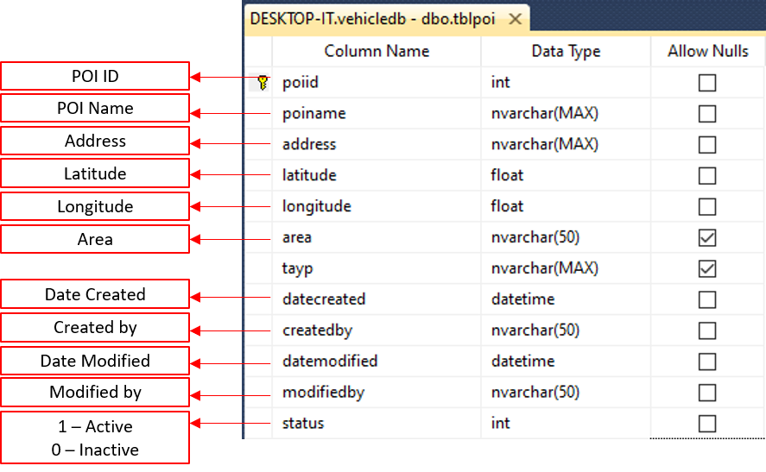

# **dbo.tblpoidistance**

* List of distance from Jpoon Whse to POI

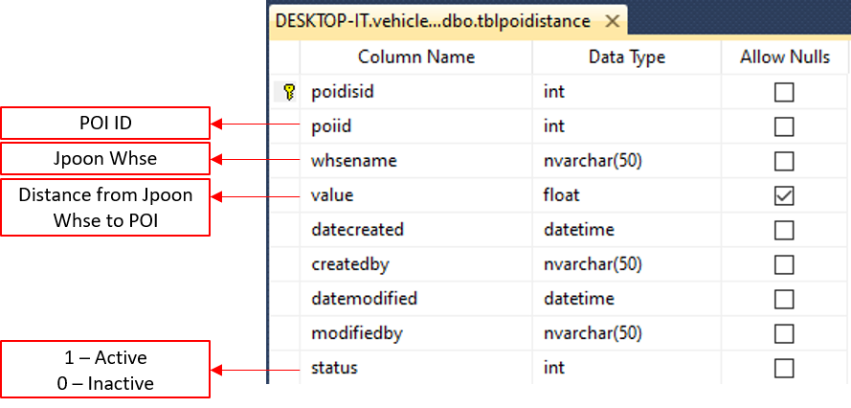

# **dbo.tblpoitags**

* 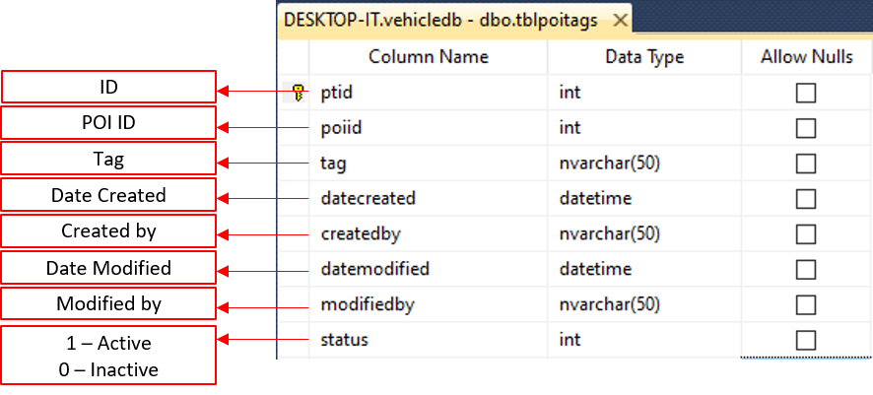List of poi tags

# **dbo.tblpoitime**

* List of Estimated Travel Time from Jpoon whse to POI (in minutes)

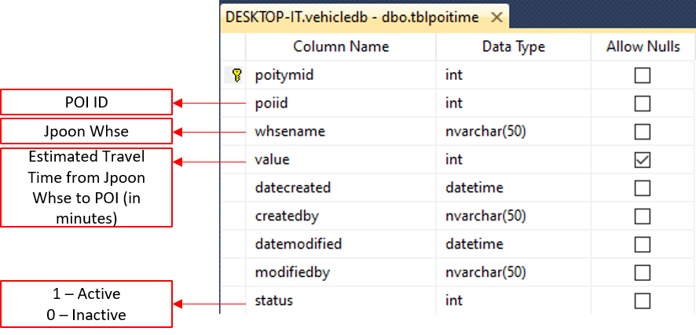

# **dbo.tblreason**

* 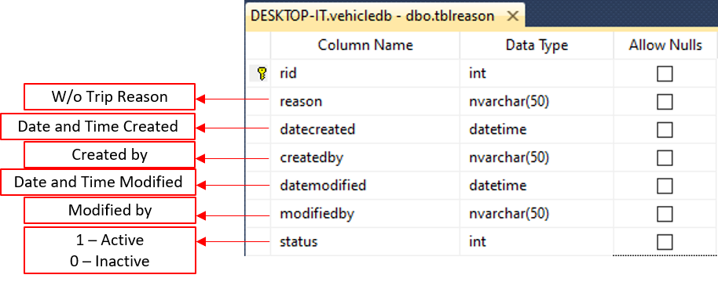List of reasons for truck status if without trip

# **dbo.tblsdraftstp9**

* Step 9 remarks history

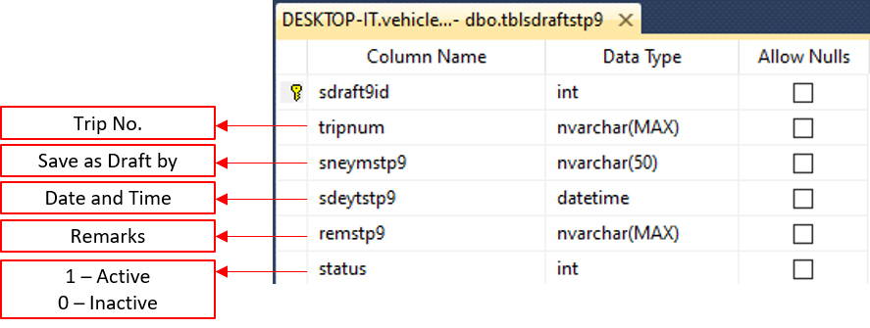

# **dbo.tbltemppoilogs**

* Update Drop off Logs

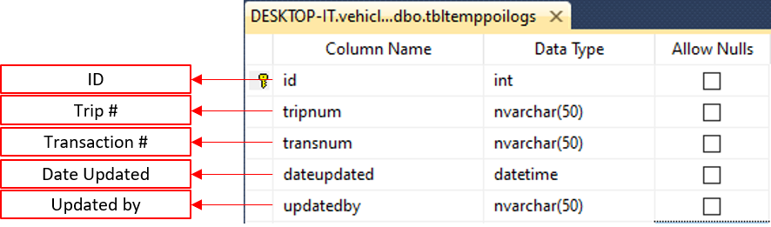

# **dbo.tbltrafficvio**

* 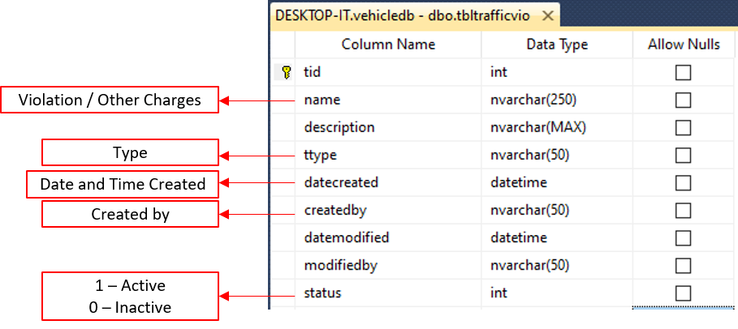List of Traffic Violation

# **dbo.tbltranstype**

* 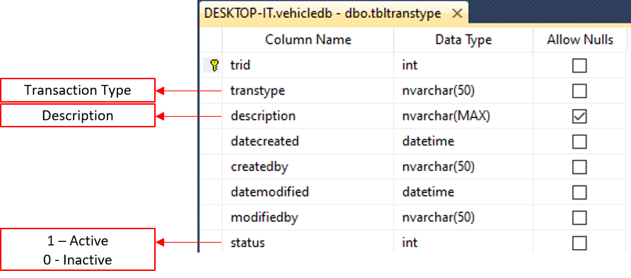List of transaction type

# **dbo.tbltripds**

* 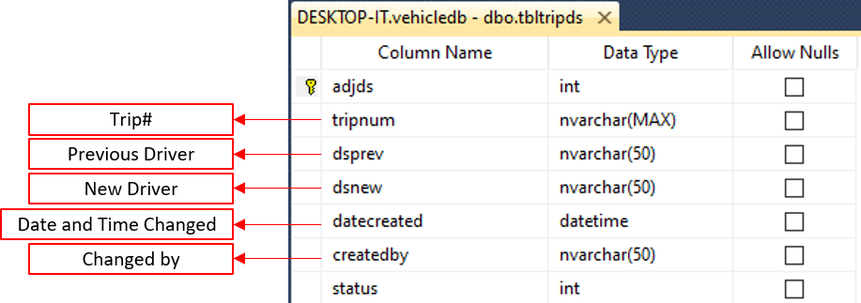Logs for editing driver in trip

# **dbo.tbltripevent**

* Check GPS if there are violations

# **dbo.tbltripeventlogs**

* GPS violation logs, events like speedup and harsh_driving

# **dbo.tbltripincident**

* List of Vehicle Accident / LTO Apprehension Report

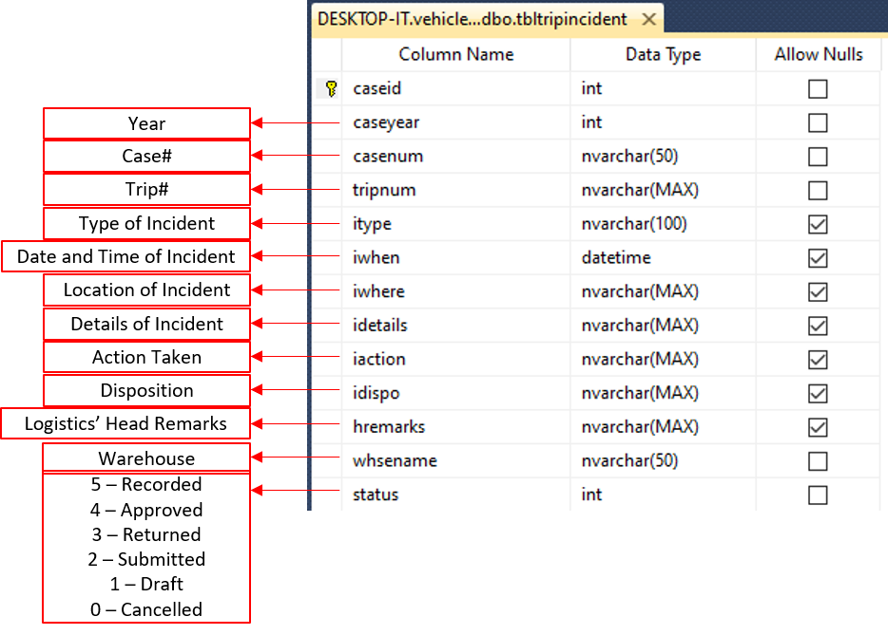

# **dbo.tbltripincidentc**

* 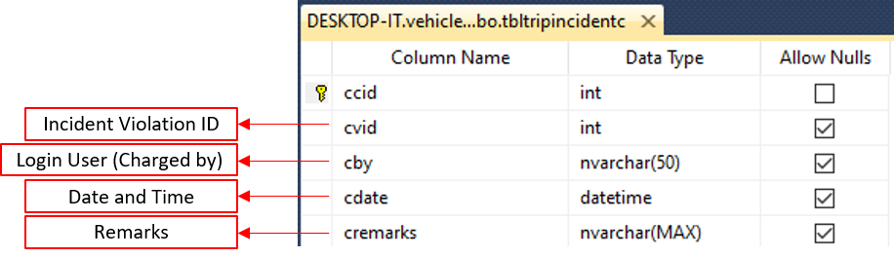List of For Charge for a specific Trip Incident Report

# **dbo.tbltripincidentlogs**

* 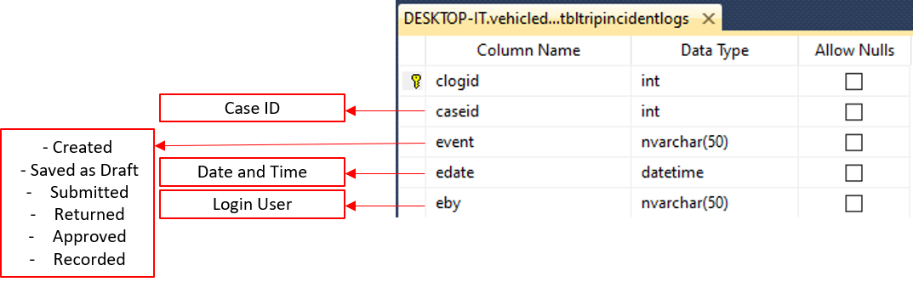Logs for Trip Incident Report

# **dbo.tbltripincidentv**

* 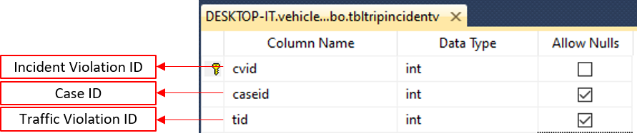List of Violations or Charges for a specific Trip Incident Report

# **dbo.tbltripitems**

* 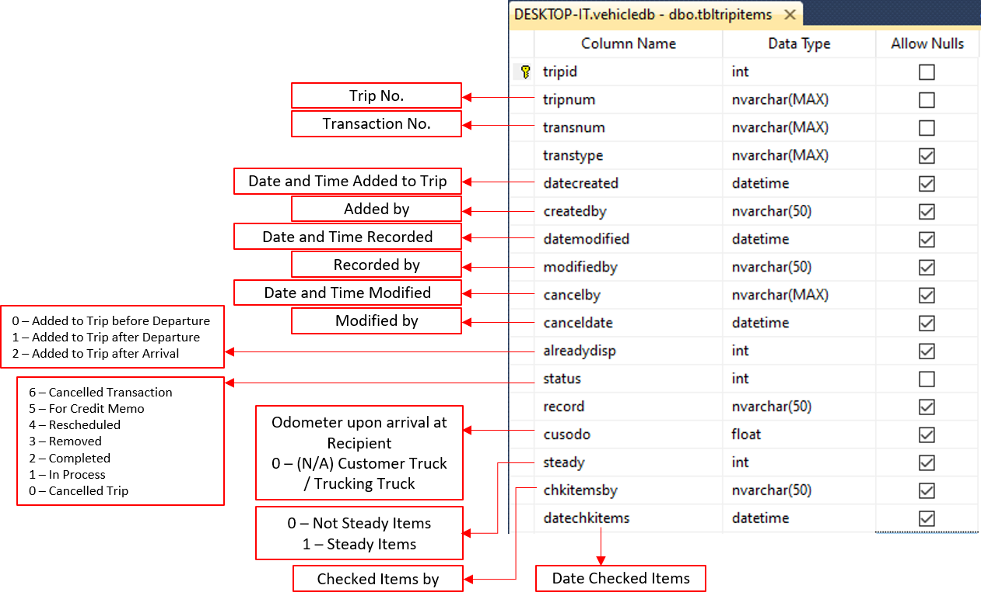List of Order Transactions added to Trip

# **dbo.tripship**

* List of Bill of Lading#

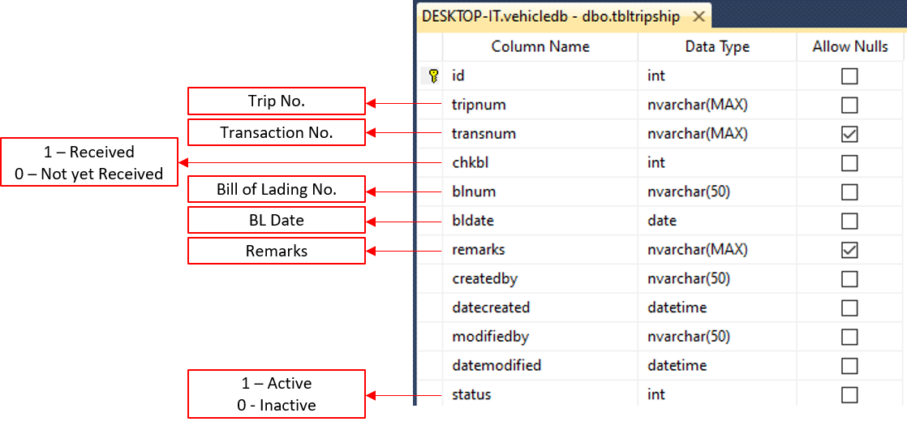

# **dbo.tbltripsum**

* Trip Summary

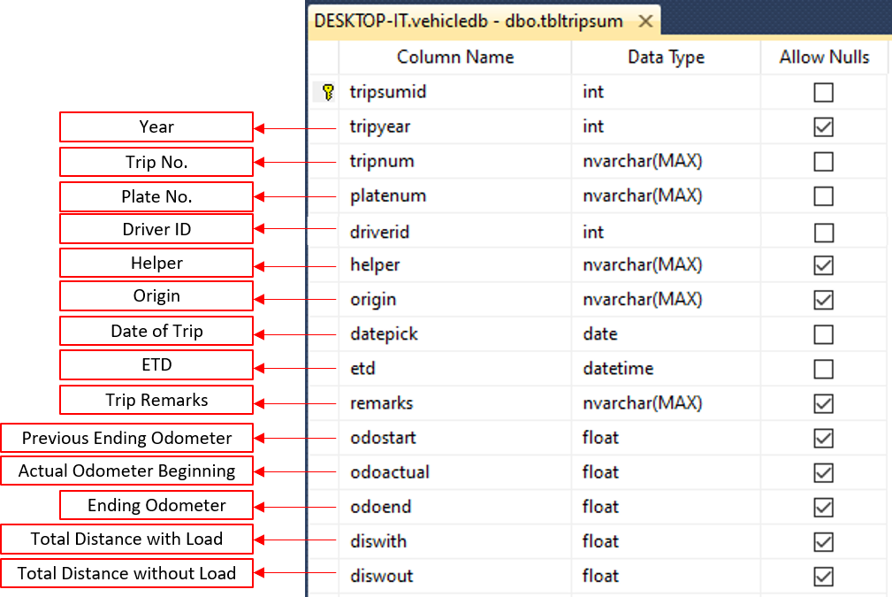

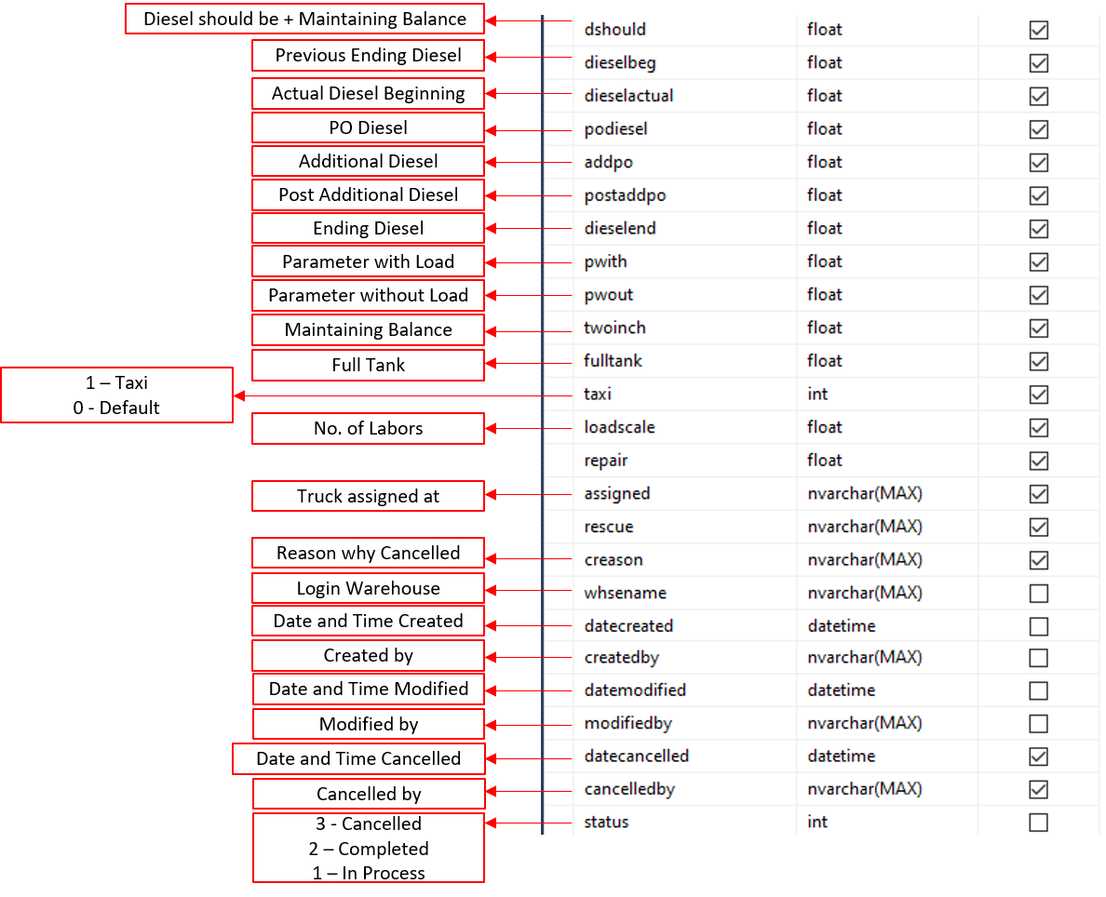

# **dbo.tbltruckstatus0**

* List of Truck Status Report#

# **dbo.tbltruckstatus1**

* 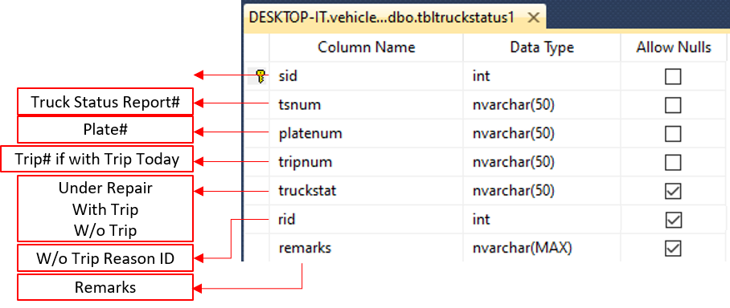List of Trucks and its status under dbo.tbltruckstatus0

# **dbo.tbltruckstatus2**

* Logs of changes made by the Logistics Staff under dbo.tbltruckstatus1

# **dbo.tblusers**

* 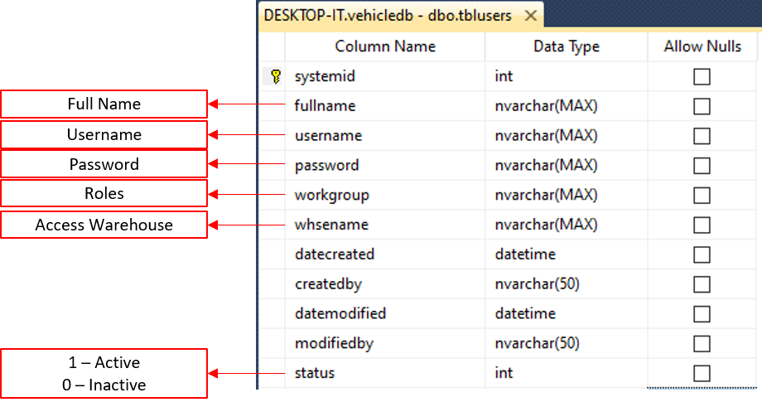List of User Accounts

# **dbo.tblversion**

* 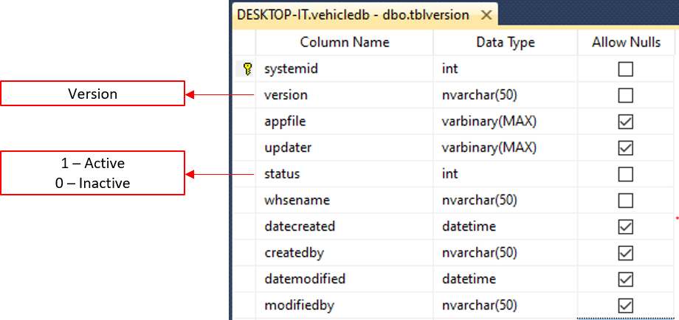List of Fleet Version

# **dbo.tblvtype**

* 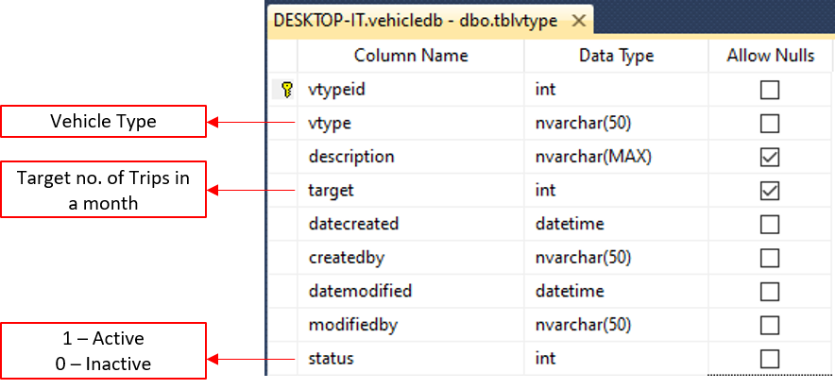List of Vehicle Type

# **dbo.tblwhse**

* 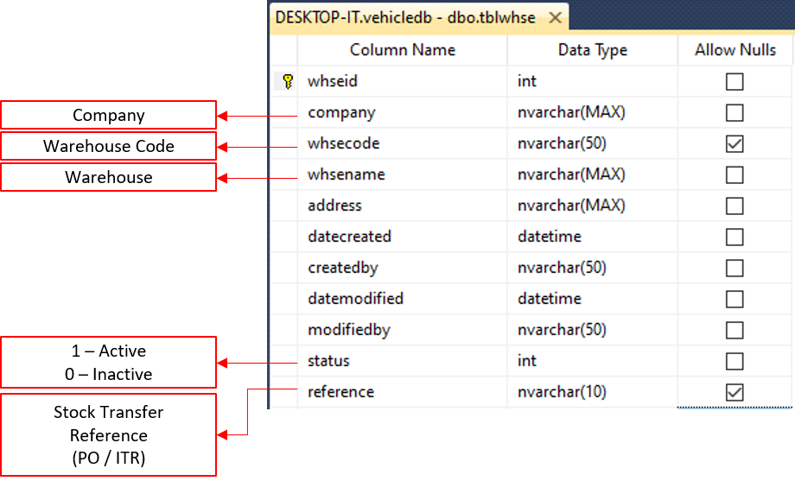List of Warehouses

# **dbo.tblwhsepoi**

* List of Pickup POI ID

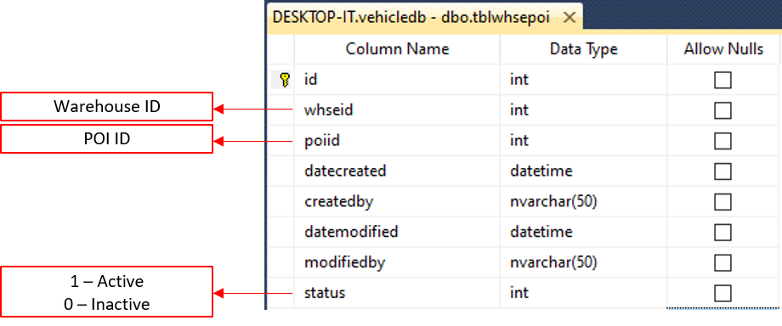

# **Database Relationship**

## Assessment

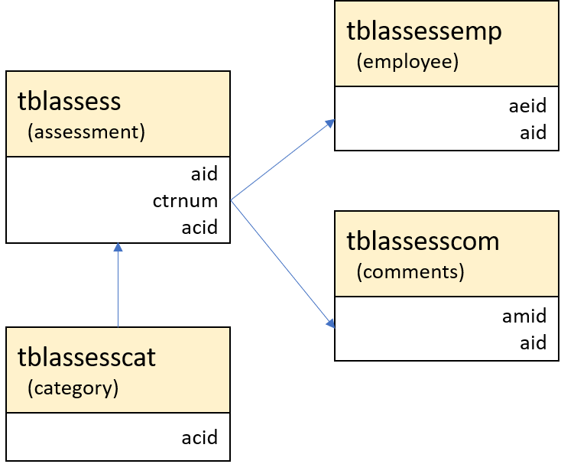

## POI

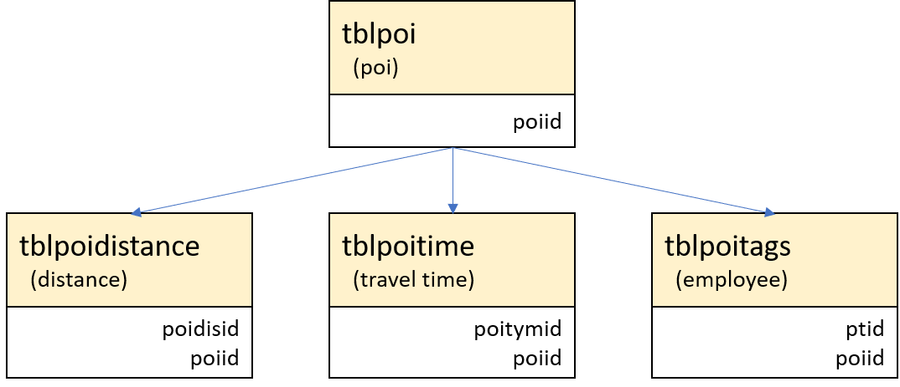

## Recipient with POI

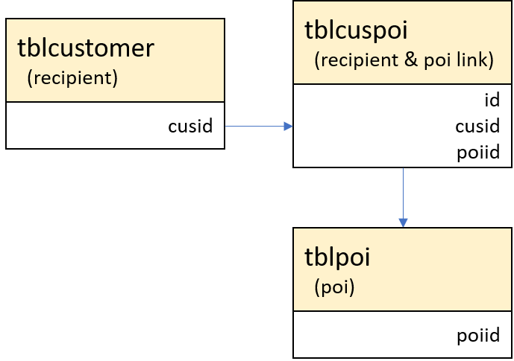

## Order Transaction

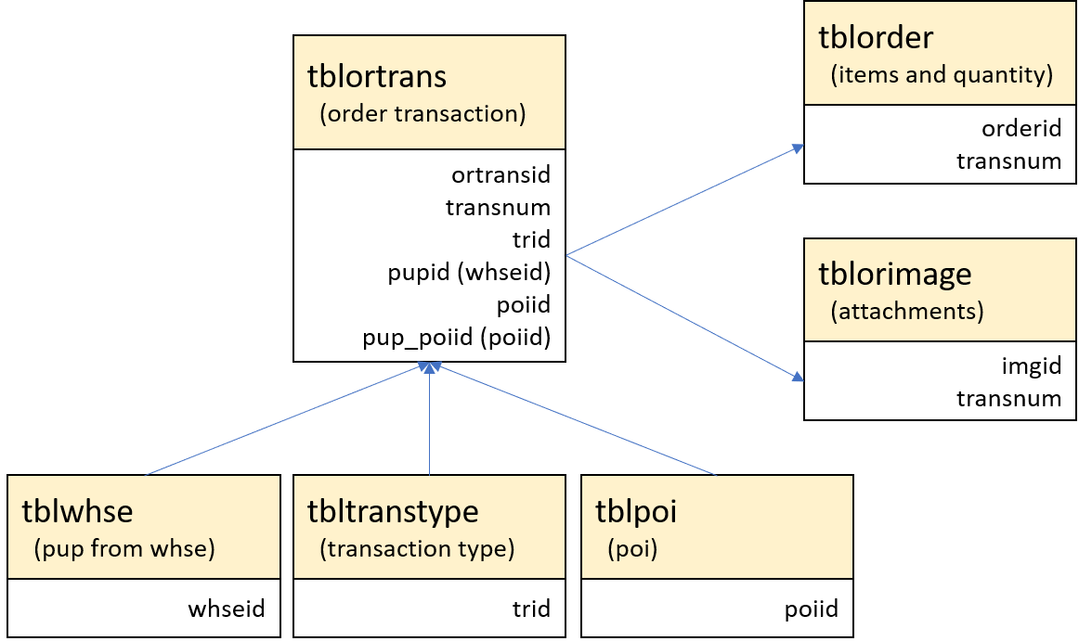

## Warehouse with POI

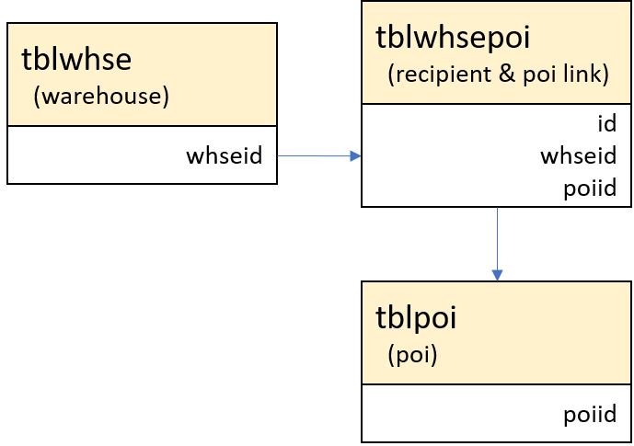

## Vehicular Accident / LTO Apprehension Report

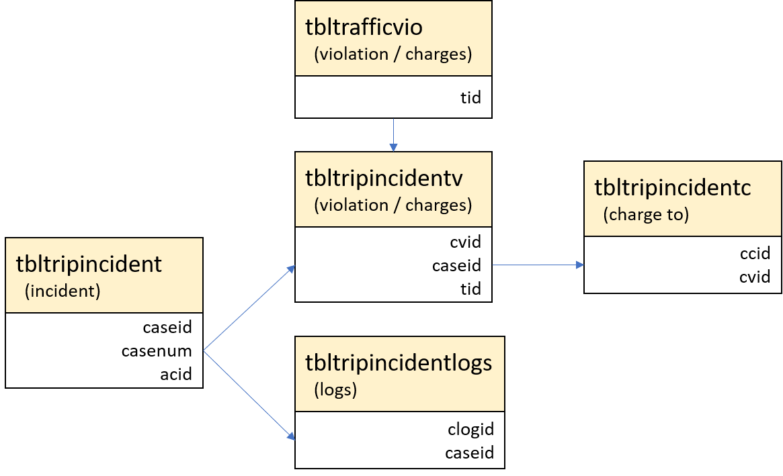

## Trip Scheduling

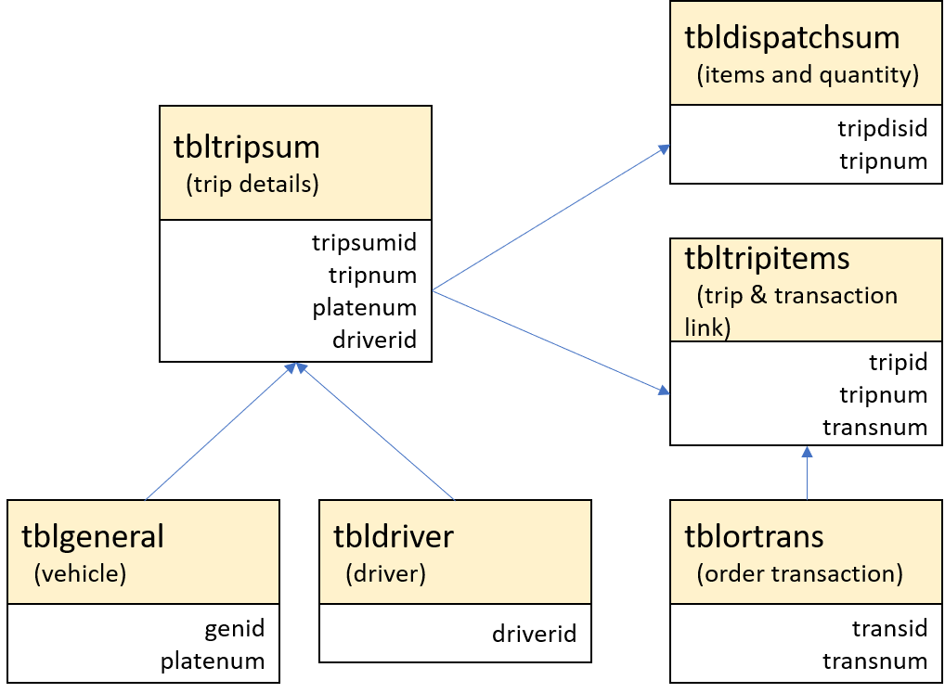

## Truck Status

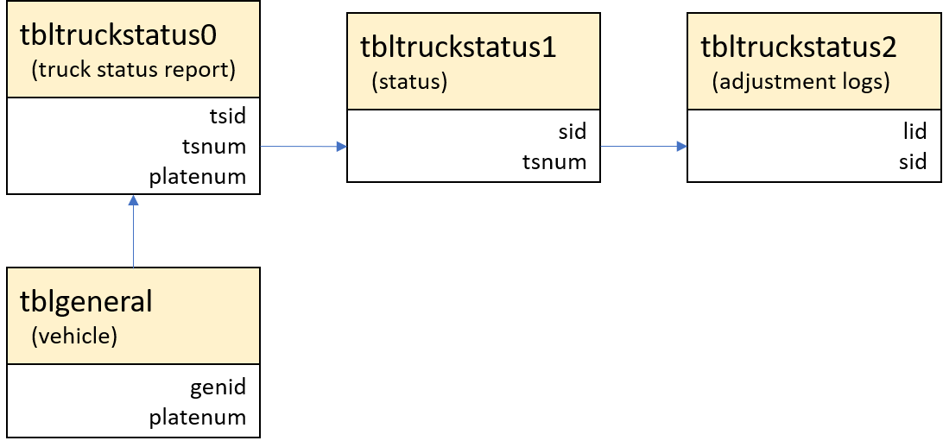

## Diesel Parameters

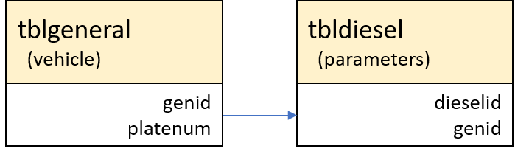

## Motorpool Inspection (Back up only)

